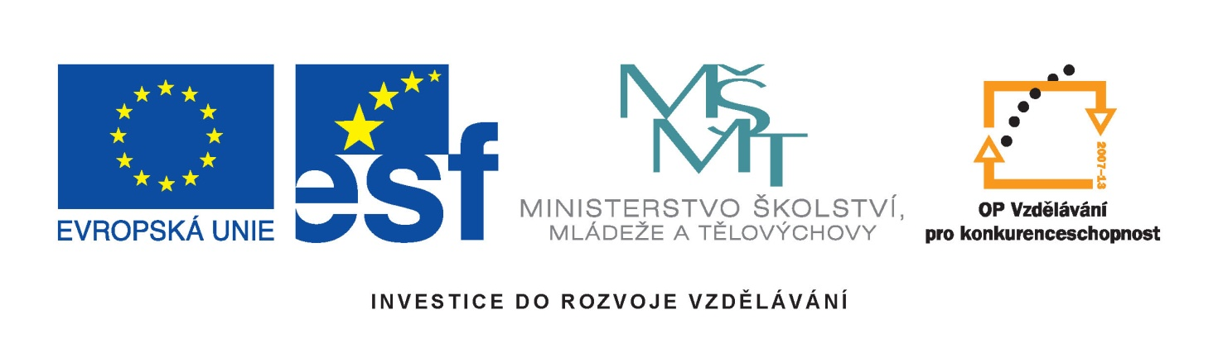



International conference
EQF referencing process in Czech Republic
Programme
11 March 2011, 9.30 – 15.30
Venue: Pyramida Hotel
Conference moderated by Miroslav Prochazka, Director of National Institute of Technical and Vocational Education (NUOV)

9.30 – 10.00 Registration, tea & coffee

10.00 – 10.15 Opening Remarks
Jindřich Fryč, Ministry of Education, Youth and Sports
Jiří Nantl, Ministry of Education, Youth and Sports

10.15 – 11.15 Presentations on EQF referencing process:
TBA, European Commission. On the importance of EQF and referencing process from the European perspective and on further development of EQF implementation
Jakub Stárek, Ministry of Education, Youth and Sports. On the referencing process in the Czech Republic.
Jitka Pohanková, National Institute of Technical and Vocational Education. On the procedure of preparing the national referencing report.

11.15 – 11.45 Coffee break

11.45 – 13.30 Results of the referencing process
TBA, Primary and secondary level of education
Věra Šťastná, Charles University. Tertiary level of education
Representative of The National Institute of Technical and Vocational Education. National qualification system (NSK)
Reviews from national experts
Karin Luomi-Messerer
Stephen Adam
Simon Field
Leona Šteigrová, Ministry of Education, Youth and Sports
Miroslav Kostka, Ministry of Labour and Social Affairs
Further development in Czech Republic
Representative of the NCP EQF CR

13.30 – 14.30 Lunch

